

LABORATORY RECORD NOTEBOOK

Name : | ...............SARVEESH B..............
Register No : | ..............2116231501148...............
Year / Semester : | IV / 7
Batch : | 2023 – 2027
Branch : | Artificial Intelligence and Machine Learning
Degree : | B. Tech.
Subject Code : | AD23731
Subject Name : | Foundations of Agentic AI
Academic Year : | 2026 – 2027 (ODD)

BONAFIDE CERTIFICATE

Certified that this is a Bonafide Record of the mini-project work done by.......SARVEESH B............ Register No…2116231501148........... of VII Semester, B.Tech. Artificial Intelligence and Machine Learning Department in partial fulfilment of the requirements of the course AD23731 – Foundations of Agentic AI during the Academic Year 2026 – 2027.

Faculty in charge

Submitted for the Practical Examination held on: ………………………

INTERNAL EXAMINER EXTERNAL EXAMINER

INDEX

Ex. No | Date | Name of the Experiment | GITHUB QR | STAFF SIGN
1 | 16/07/2026 | Design and evaluate different prompt types to control agent reasoning, autonomy, and output quality. | 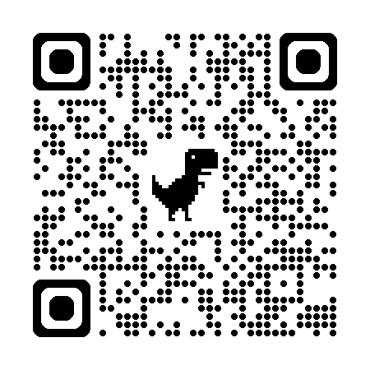
2 | 06/08/2026 | Design and implement Large Language Model (LLM)–based applications for Question Answering, Text Summarization, and Sentiment Analysis, and evaluate their performance on  realworld textual data.
3 | 20/08/2026 | Mini Project Report

